EENG 385 Workbook
Created by Dr. Christopher Coulston
Fall 2026
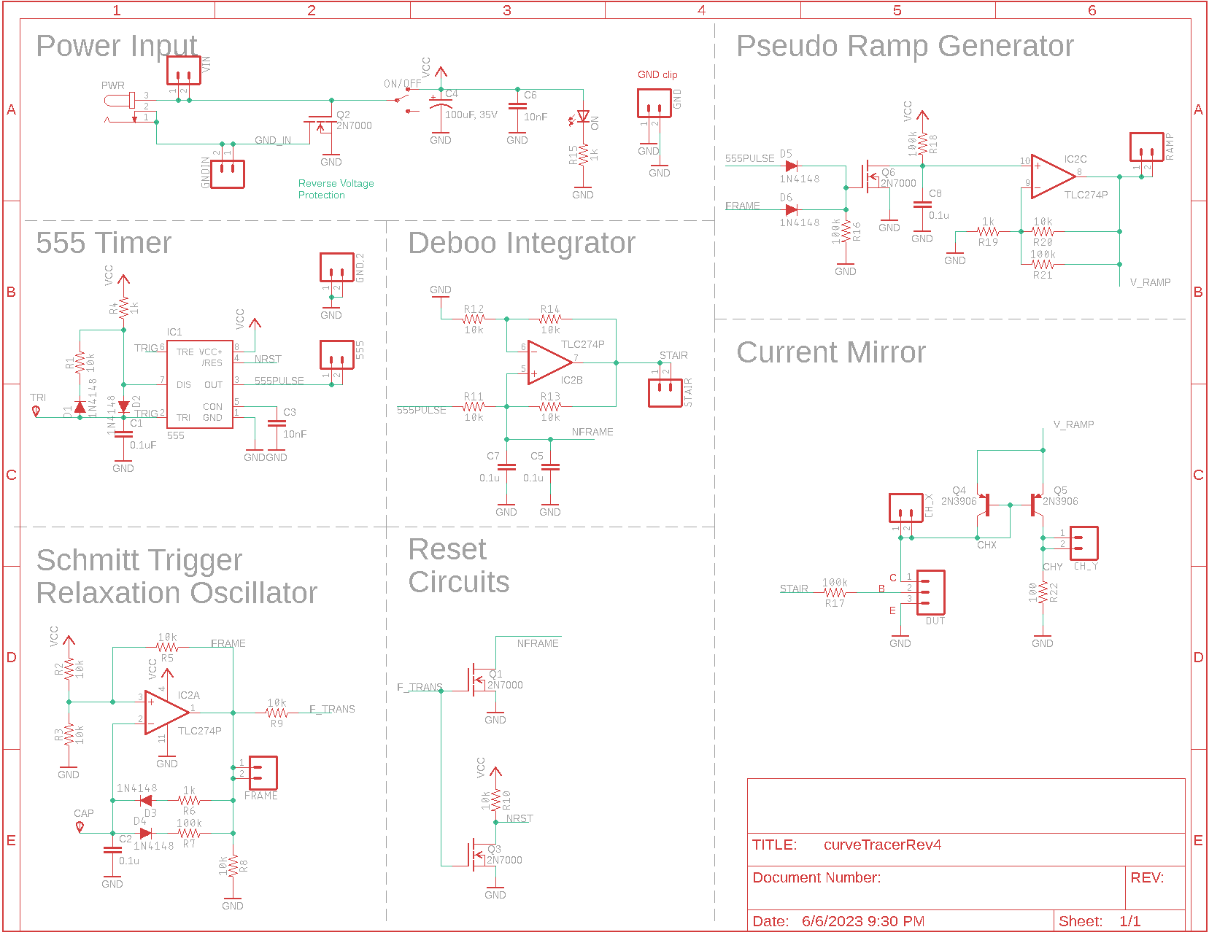

Chapter: Review

Chapter: Opamp

Chapter: Diode

Chapter BJT @ DC

Chapter: BJT @ AC
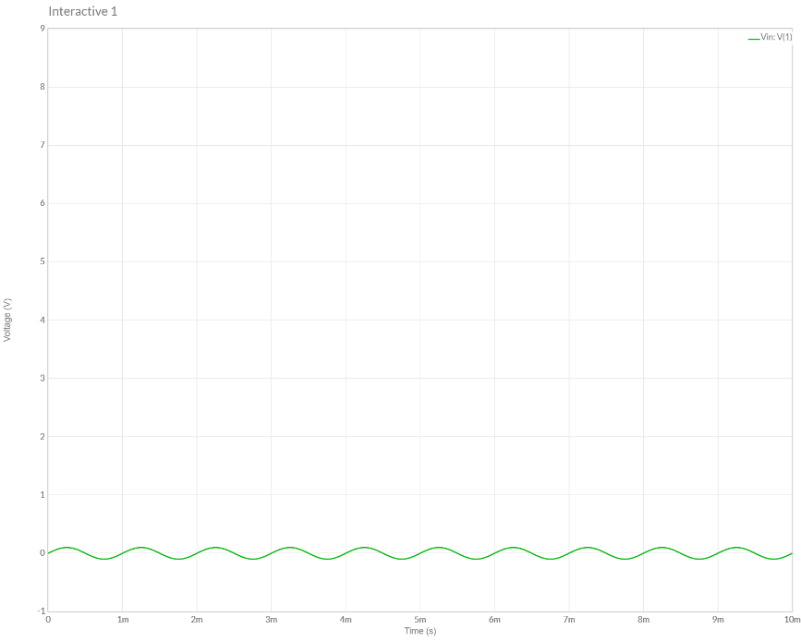

Chapter: Frequency Domain
Why does this filter output the average value of a 10kHz PWM waveform? Hint, construct the Fourier series of the 10kHz PWM wave, then consider which harmonics the filter passes and which it blocks.

Chapter: MOSFETs

